**LINUX COMMANDS**

1. **man command:** man command in Linux is used to display the user manual of any command that we can run on the terminal.

**Syntax**: man [command]

**Example:** man man

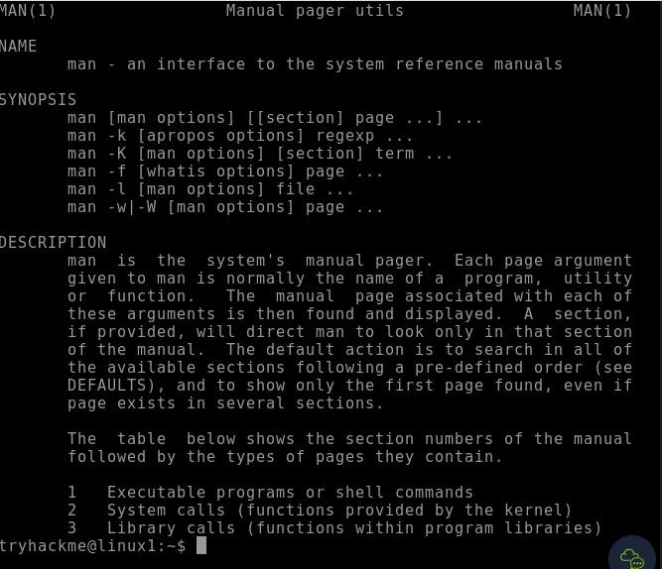

1. **whatis command**: **whatis** command in Linux is used to get a one-line manual page description.

**Syntax:** whatis [command]

**Example:** whatis pwd

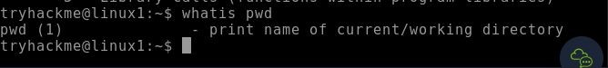

1. **date command:** **date**command is used to display the system date and time. date command is also used to set date and time of the system.

**Syntax:** date [option]…[+format]

**Example**: date –d “2000-11-20 09:10:15”

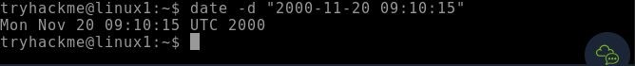

**4.** **ls command:** **ls** is a Linux shell command that lists directory contents of files and directories.  It provides valuable information about files, directories, and their attributes.

**Syntax:** ls [option] [file/directory]

**Example:** ls –l

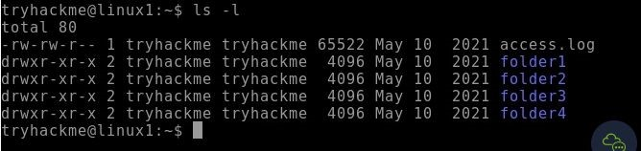

**5.** **mkdir command:** The mkdir command in Linux/Unix is a command-line utility that allows users to create new directories.

**Syntax:** mkdir [directory]

**Example:** mkdir newdocuments



**6. cd command:** Linux **cd** command is used to change the current working directory ( i.e., in which the current user is working). The "cd" stands for **'change directory.**'

**Syntax:** cd [directory]

**Example:** cd newdocuments



**7. pwd command:** The "pwd" command prints the full name (the full path) of current/working directory.

**Syntax:** pwd [directory]

**Example:** pwd

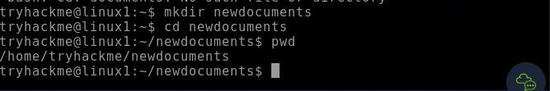

**8. rmdir command:** The rmdir command removes the directory, specified by the Directory parameter, from the system.

**Syntax:** rmdir [directory]

**Example:** rmdir newdocuments

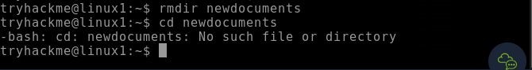

**9. cat command:** The cat (concatenate) command in Linux displays file contents. It reads one or multiple files and prints their content to the terminal. cat is used to view file contents, combine files, and create new files.

**Syntax:** cat [option] [File]

**Example:** cat dsa.txt



**10. find command:** The find command helps us to find a particular file within a directory.

**Syntax:** find [path] [option] [expression]

**Example:** find ~-name “dsa.txt”



**11. cal command:** The 'cal' term stands for calender. It displays current month's calender with current day highlighted.

**Syntax:** cal [month] [year]

**Example:** cal 02 2024

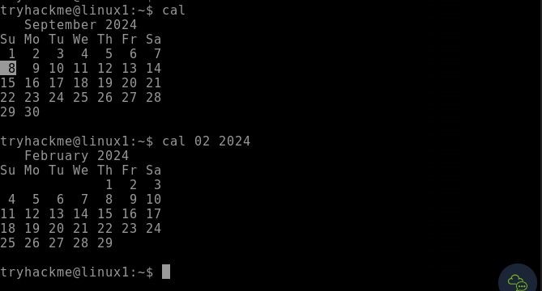

**12. grep command:** grep, short for “global regular expression print”, is a command used for searching and matching text patterns in files contained in the regular expressions.

**Syntax:** grep [options] pattern [files]

**Example:** grep –l “unix” *

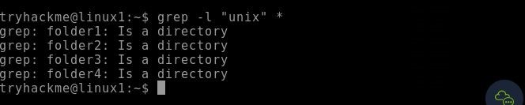

**13. echo command:** Echo is a Unix/Linux command tool used for displaying lines of text or string which are passed as arguments on the command line.

**Syntax:** echo “text”

**Example:** echo “Hello World”

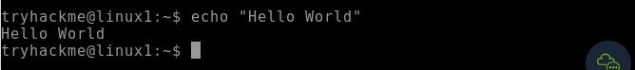

**14. ln command:**

**Syntax:** ln[OPTION]… [-T] TARGET LINK_NAME

**Example:** 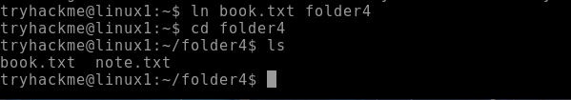

**15. rm command:**

**Syntax:** rm[file_name]

**Example:** 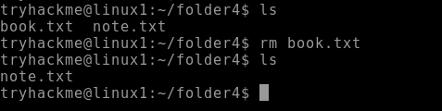

**16. rev command:**

**Syntax:** rev[option] [file]

**Example:** 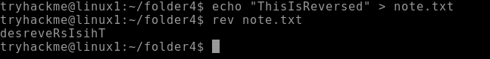

**17. paste command:**

**Syntax:** paste[option] [file]

**Example:**

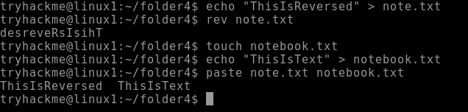

**18. cmp command:**

**Syntax:** cmp[file1] [file2]

**Example:**

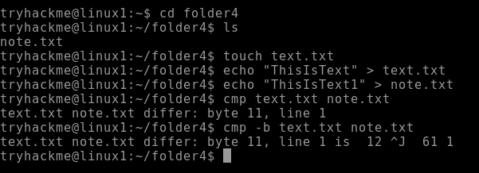

**19. id command:**

**Syntax:** id[option] [user]

**Example:** 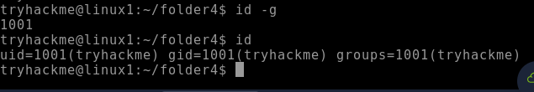

**20. chmod command:**

**Syntax:** chmod[option] [mode] [file_name]

**Example:**



**21. whoami command:**

**Syntax:** whoami

**Example: **

**22. kill command:**

**Syntax:** kill [signal] PID

**Example:**

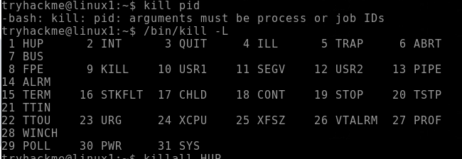

**23. wc command:**

**Syntax:** wc [option] [file]

**Example:**

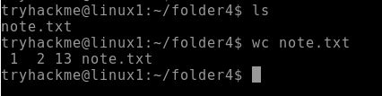

**24. head command:**

**Syntax:** head [option] [file]

**Example:**

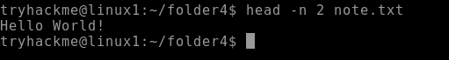

**25. id command:**

**Syntax:** id [option] [username]

**Example:**

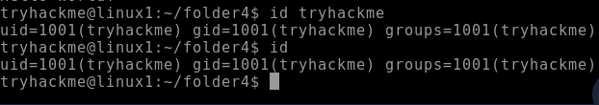

**26. tail command:**

**Syntax:** tail [option] [file]

**Example:**



**27. touch command:**

**Syntax:** touch [file]

**Example:**



**28. more command:**

**Syntax:** more [option] [file]

**Example:**



**29. less command:**

**Syntax:** less [option] [file]

**Example:**

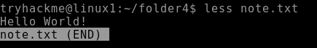

**30. ps command:**

**Syntax:** ps [options]

**Example:**

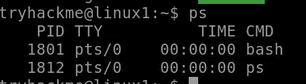

**31. cp command:**

**Syntax:** cp [options] source…destination

**Example:**



**32. mv command:**

**Syntax:** mv [options] source…destination

**Example: **

**33. cat -n command:**

**Syntax:** cat –n[filename]

**Example:**

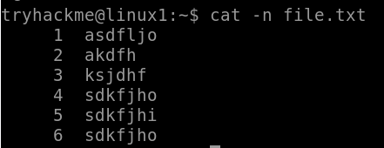

**34. cat >> command:**

**Syntax:** cat [filename1]>>[filename2]

**Example:**

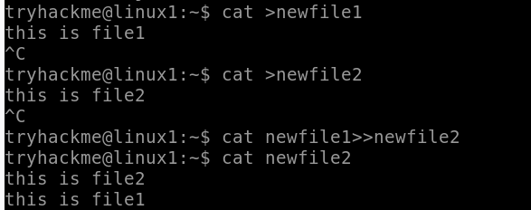

**35. join command:**

**Syntax:** join [option]…[file]…

**Example:**

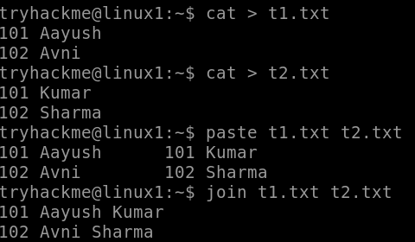

**36. wc -l command:**

**Syntax:** wc -l [option]…[file]…

**Example:**



**37. ifconfig command:**

**Syntax:** ifconfig [interface] [option]

**Example:** ifconfig cd

**38. ls -a command:**

**Syntax:** ls [option] [file]

**Example:**



**39. ln command:**

**Syntax:** ln [option] [-T] target link_name (1st form)

ln [option] target directory (2nd form)

ln [option] –t directory target (3rd form)

**Example:** ln program.py link.py

**40. killall command:**

**Syntax:** kill [signal] PID

**Example:** killall –l

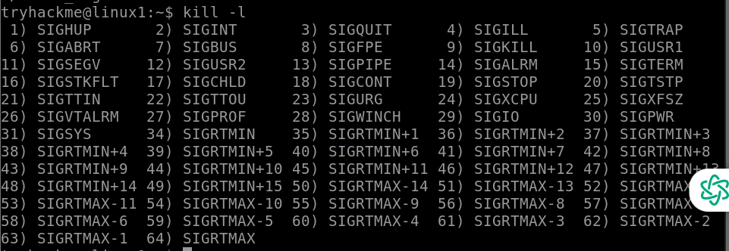

**41. kill command:**

**Syntax:** kill [signal] PID

**Example:** kill -91188

**42. ps command:**

**Syntax:** ps [option]

**Example:** ps ef

